****

**Title**

Subtitle

Author

Master thesis

Month, year

Environmental and Energy Systems Studies

LTH, Lund University

LundUniv_ENG_C2line_Black

|  |
| --- |
| Cover photo:  LUND UNIVERSITY  Department of Technology and Society  Division of Environmental and EnergySystems Studies  P.O. Box 118  SE-221 00 Lund, Sweden  ISRN xxx-xx-xx-x [Number from Petra Malmquist]  ISSN 1102-3651  Printed by Media-Tryck, Lund University |

**Sammanfattning (optional)**

Summary in Swedish (optional)

Nyckelord:

Abstract

Summary in English.

Keywords:

Preface

Här kan du tex beskriva var exjobbet har utförts och vem/vilka som varit handledare.

Contents

1 Introduction (chapter headline) 3

1.1 Headline 2 3

1.1.1 Headline 3 3

1.1.2 Equations 3

1.2 Insert picture/figure 3

1.3 Tables 3

1.4 How to make an Index in Word 3

1.5 Shortcuts in Word 3

1.6 Numbered headlines 3

2 References 3

2.1 Colours from Lund University graphic profile **Fel! Bokmärket är inte definierat.**

# Introduction (chapter headline)

**Bodytext** where every paragraph is separated by a little space vertically. Bodytext where every paragraph is separated by a little space vertically. Bodytext where every paragraph is separated

**Bodytext** where every paragraph is separated by a little space vertically Bodytext where every paragraph is separated by a little space vertically Bodytext where every paragraph is separated by a little space vertically

## Headline 2

This is **bodytext 1** where every paragraph is separated by a little indent (body text 2). The first paragraph has no indent.

This is **bodytext 2** with a little indent. This is bodytext 2 with a little indent. This is bodytext 2 with a little indent. This is bodytext 2 with a little indent. This is bodytext 2 with a little indent.

### Headline 3

#### Headline 4 (will not appear in table of contents)

Quote quote quote quote quote quote quote quote quote quote quote quote quote quote quote quote quote quote quote quote quote quote quote quote quote quote quote quote quote quote quote

### Equations

$f\left(x\right)=a_{0}+\sum_{n=1}^{∞}{\left(a_{n}\cos{\frac{nπx}{L}}+b_{n}\sin{\frac{nπx}{L}}\right)}$ (1)

## Insert picture/figure

Figures created in PowerPoint are grouped, copied and then pasted in the Word file. If that doesn’t work, you can try to save the figure as a PNG-file, and then place it in the Word file via insert picture.

1. Press enter 3 times where you want the photo.
2. Select the enter key presses (write with non-printing characters ¶).
3. Click on the format insert pictures.
4. Select the enter key press in the centre.
5. Go to insert/choose picture, find your picture on your computer and double click on it.
6. When the picture is inserted in Word, deselect the upper enter key press.
7. With the formatted picture you have the exact spacing before and after the picture, plus it will scale down proportionally to the type area.
8. Don’t forget to use the right format for the figure text under the picture

.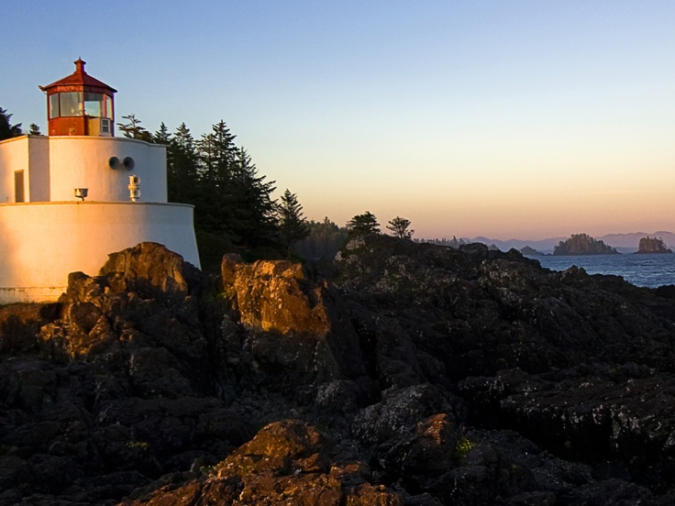

Figure 1 Picturetext (the width of the picture above is 12 cm).

## Tables

Tables are most easily created in the Word file. To make tables consistent, use the following formats:

1. Table text
2. Table text in table

Table 1 Tabeltext is better placed above the table.

|  |  |
| --- | --- |
| **OBJECT** | **NEED** |
| Format:Tabletext in table | 1 |
| Newsapaper | 3 |
| Notebooks | 1 |
| Penn | 3 |
| Scissor | 1 st. |

## How to make an Index in Word

1. Klick References – Mark index word –a new window opens
2. Now mark your words in your text, later klick on ”mark all”. Repeat until every word iare marked.
3. When you are done insert your Index by klick ”Insert Index”

## Shortcuts in Word

1. Ctrl+ Numerically minus Insert short dashes
2. Ctrl+Shift+ Spacebar Insert hard space
3. Ctrl+Shift+Hyphen Insert hard dashes
4. Alt+Ctrl+Numerically minus Insert long dashes
5. Shift+Enter Insert soft line break
6. Ctrl+Hyphen Insert soft dashes
7. Ctrl+Enter Insert pagebreak

## Numbered headlines

1. Mark the first headline in your document
2. Click start
3. Click multi-level list
4. Choose the list as picture below

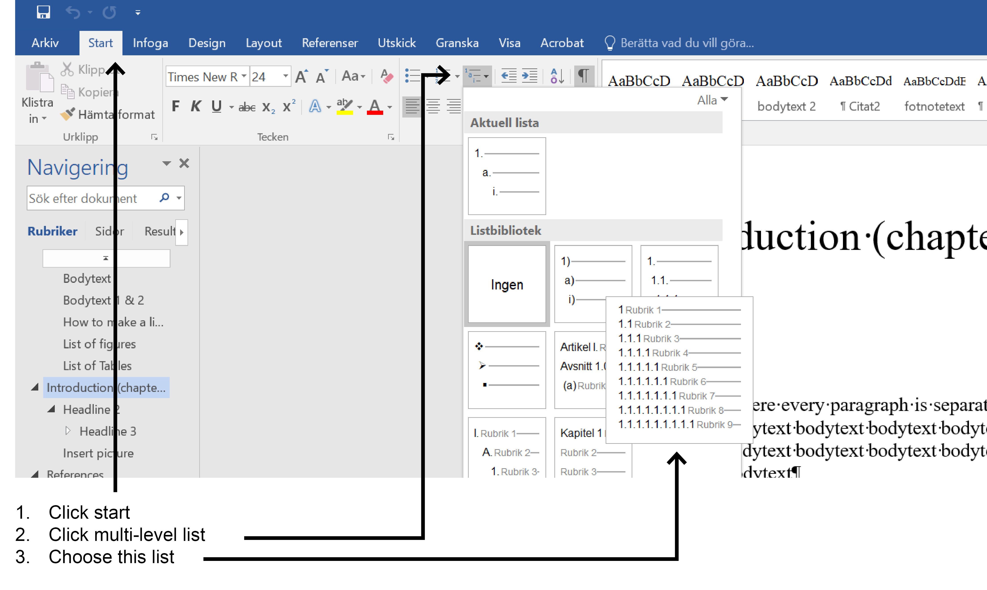

Faktaruta where every paragraph is separated by a little space vertically Bodytext where every paragraph is separated by a little space vertically Bodytext where every paragraph is separated by a little space vertically

# References

Anderson, Benedict, 1991. *Den föreställda gemenskapen. Reflexioner kring nationalismens ursprung och spridning*. Göteborg: Bokförlaget Daidalos.

Ball, William L., 1995. “*The theoretical Analysis of Policy Arguments*”. http://www.trenton.edul-ball/personal/polarg.html. 18 augusti 1996. (Paper presented at Midwestern Political Science Association, 1992.)[[1]](#footnote-1).

1. This is how the footnotes looks like [↑](#footnote-ref-1)