****

**Titel**

Undertitel

Författare

Examensarbete

Månad år

Miljö- och Energisystem, LTH

LundUniv_ENG_C2line_Black

|  |
| --- |
| Omslagsfoto:  Lunds tekniska högskola  vid Lunds universitet  Institutionen för teknik och samhälle  Miljö- och energisystem  Box 118, 221 00 Lund  ISRN xxx-xx-xx-x [Nummer från Petra Malmquist]  ISSN 1102-3651  Tryckt av Media-Tryck, Lunds universitet |

**Sammanfattning**

Sammanfattning på svenska.

Nyckelord:

Abstract

Sammanfattning på engelska.

Keywords:

Förord

Här kan du tex beskriva var exjobbet har utförts och vem/vilka som varit handledare.

Innehållsförteckning

1 Inledning 3

1.1 Headline 2 3

1.1.1 Headline 3 3

1.1.2 Equations 3

1.2 Tables 3

1.3 How to make an Index in Word 3

1.4 Shortcuts in Word 3

1.5 Numbered headlines 3

2 Referenser 3

# Inledning

Förslag på layout och fonter, men egna val kan också göras.

**Bodytext** where every paragraph is separated by a little space vertically. Bodytext where every paragraph is separated by a little space vertically. Bodytext where every paragraph is separated

**Bodytext** where every paragraph is separated by a little space vertically Bodytext where every paragraph is separated by a little space vertically Bodytext where every paragraph is separated by a little space vertically

## Headline 2

This is **bodytext 1** where every paragraph is separated by a little indent (body text 2). The first paragraph has no indent.

This is **bodytext 2** with a little indent. This is bodytext 2 with a little indent. This is bodytext 2 with a little indent. This is bodytext 2 with a little indent. This is bodytext 2 with a little indent.

### Headline 3

#### Headline 4 (will not appear in table of contents)

Quote quote quote quote quote quote quote quote quote quote quote quote quote quote quote quote quote quote quote quote quote quote quote quote quote quote quote quote quote quote quote

### Equations

$f\left(x\right)=a_{0}+\sum_{n=1}^{∞}{\left(a_{n}\cos{\frac{nπx}{L}}+b_{n}\sin{\frac{nπx}{L}}\right)}$ (1)

.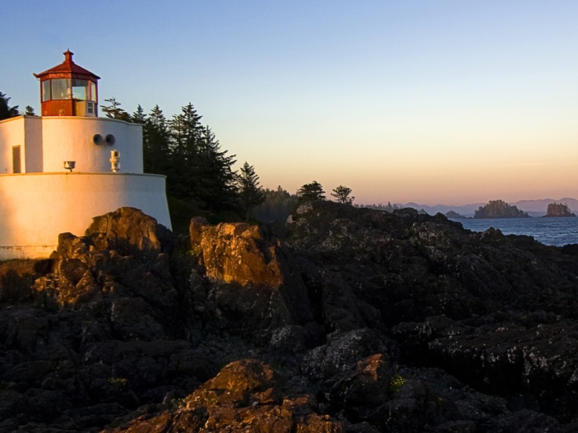

Figur 1. Figurtext under figuren.

## Tables

Tabell 1 Tabeltext ovanför tabellen.

|  |  |
| --- | --- |
| **OBJECT** | **NEED** |
| Format:Tabletext in table | 1 |
| Newsapaper | 3 |
| Notebooks | 1 |
| Penn | 3 |
| Scissor | 1 st. |

## How to make an Index in Word

1. Klick References – Mark index word –a new window opens
2. Now mark your words in your text, later klick on ”mark all”. Repeat until every word iare marked.
3. When you are done insert your Index by klick ”Insert Index”

## Shortcuts in Word

1. Ctrl+ Numerically minus Insert short dashes
2. Ctrl+Shift+ Spacebar Insert hard space
3. Ctrl+Shift+Hyphen Insert hard dashes
4. Alt+Ctrl+Numerically minus Insert long dashes
5. Shift+Enter Insert soft line break
6. Ctrl+Hyphen Insert soft dashes
7. Ctrl+Enter Insert pagebreak

## Numbered headlines

1. Mark the first headline in your document
2. Click start
3. Click multi-level list
4. Choose the list as picture below

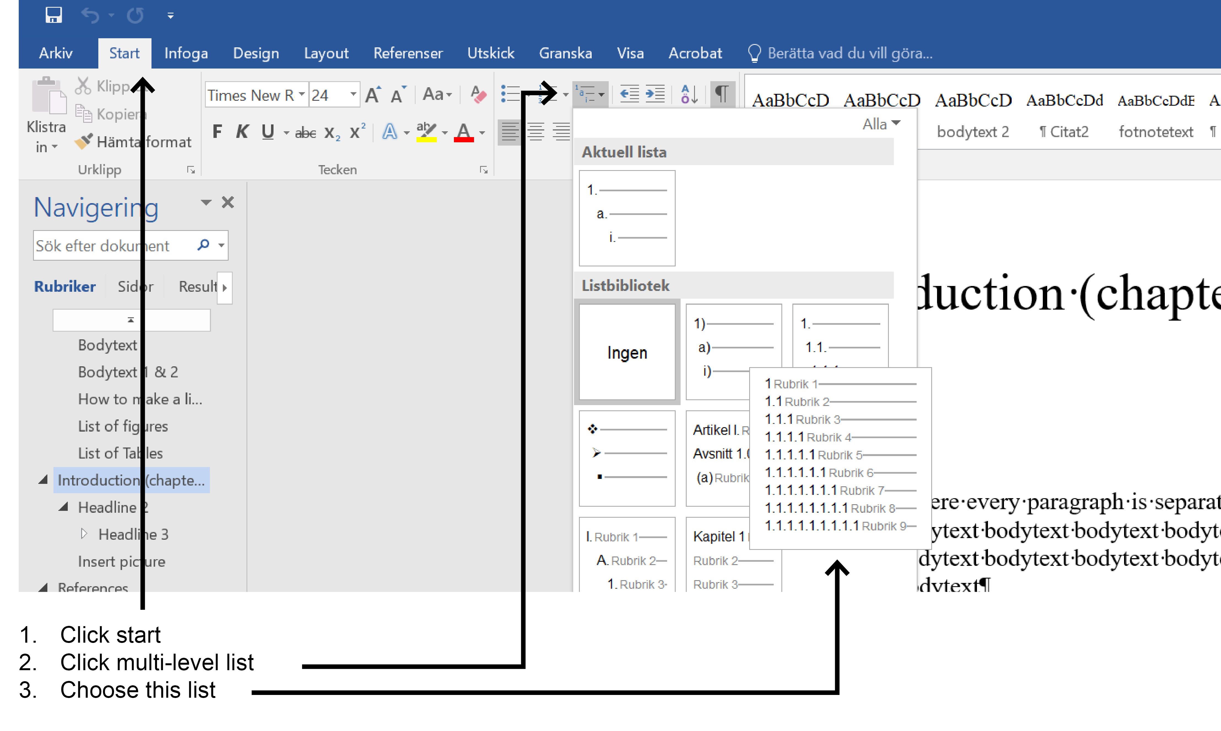

Faktaruta where every paragraph is separated by a little space vertically Bodytext where every paragraph is separated by a little space vertically Bodytext where every paragraph is separated by a little space vertically

# Referenser

Anderson, Benedict, 1991. *Den föreställda gemenskapen. Reflexioner kring nationalismens ursprung och spridning*. Göteborg: Bokförlaget Daidalos.

Ball, William L., 1995. “*The theoretical Analysis of Policy Arguments*”. http://www.trenton.edul-ball/personal/polarg.html. 18 augusti 1996. (Paper presented at Midwestern Political Science Association, 1992.)[[1]](#footnote-1).

1. This is how the footnotes looks like [↑](#footnote-ref-1)